



DETAILED SPECIFICATIONS

**REDESIGN OF EASIA TRAVEL BtoB WEBSITE**



**Easia Travel**

European office:

Centre d'Affaires du Molinel - Bât A - Avenue de la Marne

59290 WASQUEHAL - FRANCE

1- Easia Travel presentation 3

1.1 Company 3

1.2 Objectives 3

1.3 Our main competitors 3

1.4 Current BtoB website 3

1.5 Current BtoB website problems 4

2- Project presentation 4

2.1 Objectives of the new BtoB website 4

2.2 Roles of the contractor 5

2.3 Roles of Easia Travel 5

2.4 Contact 5

3- General expectations 6

3.1 Ergonomics 6

3.2 Web pages format 6

3.3 Graphic identity 6

3.4 Statistics consultation tool 6

3.5 Training 7

4- Web tree and expected functionalities 7

4.1 Homepage 7

4.2 Zoning 8

4.3 Destinations Menu 10

4.4 Practical Menu 12

4.5 Clients and Easia Travel comments 17

4.6 Product Fact sheets 17

5- Technical expectations 19

5.1 Technical solution 19

5.2 Users Management and Access Control 19

5.3 General search engine 20

5.4 Content filters 21

5.5 Hosting 22

5.6 Contents migration 22

5.7 Maintenance and warranty services 23

5.8 Security 24

6- Service provider selection 24

6.1 Main expectations of the Btob website 24

6.2 Financial and technical proposals 24

6.3 Criteria for proposals selection 25

6.4 Proposals submission 25

6.5 Execution method 25

7- Method 26

7.1 Provisional schedule 26

7.2 Expected deliverables 26

7.3 Budget 26

7.4 Rights and property 26

## 1- Easia Travel presentation

### 1.1 Company

Easia Travel was created in 2000 by 3 travel professionals: NGUYEN Thuy Hoa, VU Huy and Philippe RICHARD.

Easia Travel is a receptive travel agency in **Vietnam, Cambodia, Myanmar, Laos**.

We design tours for **travel professionals only** (tour operators and travel agencies) in the respect of the distribution network.

We offer tailor-made tours for individuals, groups, incentive and seat-in-coach tours.

Our offices are located in Southeast Asia and in Europe (France, Germany, Italy, UK…).

We work on the following markets: France, Germany, Italy, Spain, UK…

### 1.2 Objectives

Easia Travel key issues and strategic axes for the short and medium terms are :

* Differentiate from the competition (tours, service quality and advices...)
* Continue to acquire new clients
* Improve relationships with clients
* Create customer loyalty
* Improve the BtoB website responsiveness, and boost the competitiveness and added value of Easia Travel
* Open new destinations and expand its business
* Offer better training to the teams and clients

### 1.3 Our main competitors

|  |  |
| --- | --- |
| Company | URL |
| Exotissimo | BtoB website: [www.traveltrade.exotissimo.com](http://www.traveltrade.exotissimo.com) |
|  | Website: [www.exotissimo.com](http://www.exotissimo.com) |
| Trails of Indochina | <http://www.trailsofindochina.com> |
| Buffalo tours | <http://www.buffalotours.fr> |
| Phoenix voyage | <http://www.phoenixvoyages.com> |
| Asco lotus | <http://www.ascolotus.com> |
| Vidotour | <http://vidotourtravel.com> |
| Asian Trails | <http://www.asiantrails.travel> |

### 1.4 Current BtoB website

The current BtoB website is: [www.easia-pro.com](http://www.easia-pro.com)

The initial BtoB website project was created in June 2008 in order to improve the relationship between Easia Travel and clients, and strengthen their common business. It was launched online in 2011.

It was developed in Vietnam with **Visual Studio** software, in **ASP.net language**.

The current BtoB website is dedicated to our clients (travel professionals: **travel agencies** and **tour operators**) and our teams.

To access the website, it is necessary to have a password, provided in advance by Easia Travel.

Double utility of the BtoB website:

* For the client: source of information, examples of programs, access to tariffs, pictures, product fact sheets, etc.
* For the staff: access to information and programs, destinations, tariffs, internal notes, internal documents, etc.

### 1.5 Current BtoB website problems

* Ergonomics, web tree and navigation => not « user-friendly » enough
* Search engine => lack of efficiency, not functional, not really intuitive, problems with keywords input (uppercase, accents...)
* The loading time is too long (product fact sheets, pictures, etc.)
* Website access => no customized passwords
* Product fact sheets download => difficult to update, problem with the layout
* In the current back office: impossible to preview the new content created before it’s online => back and forth between the back office and front office is needed

## 2- Project presentation

### 2.1 Objectives of the new BtoB website

* Optimize the current BtoB website to make it more functional, more intuitive and have a better browsing => make it more "**user-friendly**"
* Optimize the **website speed** (downloading, access to the pages, etc.)
* Create **individual passwords** per person (personalized passwords system)
* **Customize** the BtoB website for the main clients
* Make the integration easier for new sections. And create a website (**back office** and **front office**) which allows an easy **corrective and upgradeable maintenance**
* Give clients the option to write comments in different sections of the website
* Make the website **functional** for computers and tablets **devices**. The responsive design question is to be raised
* Have the possibility **to connect the BtoB website to a CRM** to be able to have a personal client service

### 2.2 Roles of the contractor

* Develop and implement the BtoB website according to the web tree provided by Easia Travel
* Fit to a web presentation the content provided by Easia Travel (wireframes, functional kinematics, etc.)
* Respect Easia Travel’s corporate identity charter (logo, colors, etc.)
* Create/improve the graphic design (background pages, buttons, icons, etc.)
* Include a general search engine in the website and specific search engines in some sections
* Create **specific functionalities** (interactive maps, award system, etc.)
* Take into account that **several languages** will be integrated later: the website will be translated into French, German, Italian…
* Provide a project completion schedule in accordance with Easia Travel
* Respect the delivery date of the website
* **Train** Easia Travel staff in charge of updating the website and of the technical maintenance
* Incorporate an efficient tool for statistics analysis
* Propose a suitable **English-speaking** hosting solution, which will improve the speed connection for our clients in Europe and United States, and our staff in Asia.

### 2.3 Roles of Easia Travel

* Provide contents (texts, brochure, logos, pictures, videos, etc.) that the service provider will require to design the website
* Approve the service provider proposals at each step (graphic design, ergonomics, content)
* Ensure the respect of the Requirements
* Ensure the respect of the deadline

### 2.4 Contact

The project team is composed of the following people:

* Mr Maxime Temperman, Web Project Manager
* Miss Camille Favrot, Marketing & Communication Manager
* Mr Philippe Richard, Easia Travel France Director

For technical and operational questions, the service provider should first contact:

* Mr Maxime TEMPERMAN

Project Web Manager

Tel: +33 3 20 13 08 21

Mail: [weblillea@gmail.com](mailto:weblillea@gmail.com)

* Mlle Camille FAVROT  
  Marketing & Communication Manager  
  Tél: +33 3 20 13 08 21  
  Mail: [camille@easia-travel.com](mailto:camille@easia-travel.com)

## 3- General expectations

### 3.1 Ergonomics

The selected service provider must provide **an intuitive and easy-to-use website**, with direct access to the desired content.

Wherever possible, we would like to avoid using the scrollbar.

### 3.2 Web pages format

The website will be designed to fit different screen sizes and different devices (computers, tablets…). The display will suffer no degradation and will not require the use of the functionality of zoom or a different type of resizing.

The same information will be available and organized differently depending on the type of device that is used.

=> The Smartphone format is to study. The service provider can give us his opinion on the subject and give us a rough quote **with and without responsive web design**.

**Flash technology must be avoided if possible.**

### 3.3 Graphic identity

* The graphic design has to illustrate Easia Travel identity: respect Easia Travel’s corporate identity charter in the website.
* Keep a professional visual identity. The website pages have to be **clear and uncluttered**, and not too busy.
* Pictograms are needed (around 15 maximum) in different sections of the website.

The service provider can propose a selection of pictograms and their position in the website.

Our newsletter already contains pictograms – the provider may get inspiration from them if needed.

*See Annex ‘Easia Travel’s corporate identity charter’ *

### 3.4 Statistics consultation tool

* We want to be able to monitor general website visiting statistics.
* Ideally, we would like an individualized statistics consultation tool that allows monitoring each user browsing.

The objective is to analyze and monitor users navigation, and to see which sections they visit the most, in order to adapt the content of the website to our clients needs.

This is especially interesting for us for the e-learning section, to know who has followed the e-learning (client and staff).

**Monitoring must be individualized**.

The service provider can propose a suitable solution.

The tag code will be sent to Easia Travel (at the launch of the project) for future integration into new content.

### 3.5 Training

The offer will include a training to Easia Travel administrators on the website utilization.

Easia Travel will identify up to 5 people who can manage the website and then train new users.

The offer will also include trainings in digital format, acting like instructions manuals.

## 4- Web tree and expected functionalities

The web tree must be extensible in order to add new contents and sections from the back office.

The different zonings presented in Annex have been designed to model parts of the website and provide an overview of the design and functioning.

**These zonings are not a guide to future graphic design.**

For the detailed website tree and the different sections:

*See PDF Annex*

* VIETNAM DESTINATIONS MENU:
  + VIETNAM PRODUCT FACT SHEETS
  + VIETNAM TOURS & TARIFFS
  + VIETNAM USEFUL INFORMATION
* PRACTICAL MENU

### 4.1 Homepage

The contents of the homepage should appear entirely on one page – no need to scroll down the screen.

New products (= last additions) will need to appear in the content area.

**The service provider should be force of proposal on the choice of the display format.**

* See Annex : Zoning PowerPoint : ‘1- Homepage’ *

### 4.2 Zoning

The different navigation zones will be well defined and quickly identifiable.

**On all the website pages,** theLogo, Header, Destinations Menu, Quote and Practical Menu will remain in the same place.

**Only the Content area will change.**

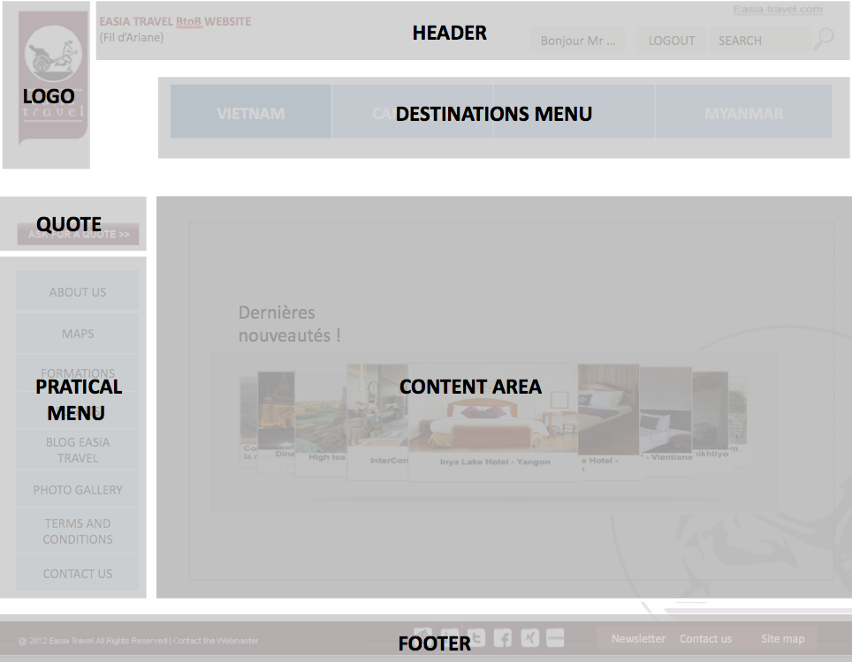

**1) Logo**

* It will be present on all the website pages, as visible as possible.
* It will be clickable to return to the homepage at any time.

**2) Header**

It will include:

* The website name = EASIA TRAVEL BtoB WEBSITE
* The breadcrumb trail
* For all clients: Hello Mr., Mrs. X… (Depending on the password used)
* The logout button
* The general search engine bar
* A link to the corporate website: easia-travel.com

**3) Destinations Menu**

Entry by destinations: Vietnam, Cambodia, Laos, Myanmar.

Horizontal navigation bar referring to the 4 destinations.

Possibility to add destinations in a close future.

**4) Quote**

The tab 'Request a quote' will send to the quote forms.

*See Word Annex: ‘FIT Request Form Vietnam’*

The content of these forms will not change, but **the contractor will be in charge of choosing the format, layout and design.**

**Details of this section:**

* When clicking on ‘Request a Quote’:

In the content area, several segments displayed: **FIT, GIT, MICE**

* When clicking on a segment, we arrive at:

**- Information request** (page 1)**:**

**Common section for all the quote forms,** with information to complete (file name, date, arrival, departure, etc.).

**Memory seizures will be active** and offer choices as a tab down.

**A selection of 4 destinations** will be proposed at the end of the common section, for travel combination possibilities (=> the user can choose one or multiple destinations).

* By clicking on one or several countries, we arrive at:

**- Proposals to check**: one thematic question per page (attractions, activities, accommodation types, etc.) with boxes to tick.

This part of the form will be adaptable according to the selected destinations.

The presented products will display **links to the Product fact sheets**.

At the end of each thematic question a "**Next” button** validation will lead to the next question.

If the user chooses several destinations at the end of the common section:

Ex : Vietnam, Laos and Cambodia

=> the thematic questions for Vietnam are displayed first, then questions for Laos, then for Cambodia.

Once all the fields are filled in, the client can validate his quote and **an automatic alert will be sent to our sales team**.

**A progression bar** will be displayed.

**5) Practical Menu**

Vertical navigation bar referring to specific sections:

About us, Maps, Training, Flights, Blog, Photo gallery, Terms & conditions, Contact us

**6) Content area**

This area will contain the specific content for each page:

* Its size should be fixed on all pages
* It should be **as large as possible**

**7) Footer**

* It will contain links and images
* It will be possible to add or remove elements

Footer will include:

* Link to the sitemap
* Links to social networks (Facebook, Twitter, Linkedin, Viadeo, Pinterest, Xing, The Hub)
* Newsletter => registration form and access to previous newsletters
* Contact us
* Legal Notice (is it necessary for a BtoB website? => to be confirmed by the contractor)

**Note : Destination menu and Practical menu will be independent each other.**

### 4.3 Destinations Menu



Horizontal navigation bar with 4 destinations

Entry by destination:

* Vietnam
* Cambodia
* Laos
* Myanmar

**Allow the addition of other destinations in the future.**

**Notes:**

* This menu will be fixed throughout the website navigation.
* The deployment of sub-sections shall not interfere with the visibility of other elements of the website (transparency effect)
* The sections have to be **clickable** and allow **“Mouseover” / ”Mouseout”**.

See examples of the 'Mouseover' & 'Mouseout' system:

<http://www.hortik.com>

<http://www.vertbaudet.com>

* The tab where the user navigates shall **be highlighted**
* The sub-menus will **close** when another section is clicked or when the cursor leaves the ‘action zone’
* The number of sections and sub-sections will vary (depending on extensions, countries, etc.). The administrator will be able to add, move, modify and/or delete each section in the administration interface.
* **Sections**

When the mouse cursor passes over or click on a country => a drop-down menu will appear below, displaying the following sub-sections:

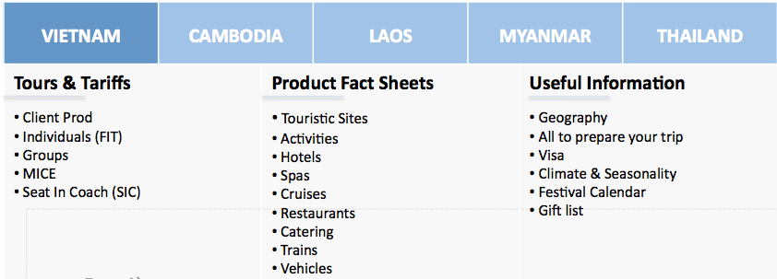

* Tours & Tariffs
* Product Fact sheets
* Useful Information

The country that the user clicked will be **highlighted.**

**The drop-down menu will disappear** when the user leaves the ‘action zone’.

* See Annex for navigation system: Zoning PowerPoint: ‘1- Homepage’ *

* **Sub-sections**
* **Tours & Tariffs**
* My Production *(For the ‘main’ clients only: history of the programs specially designed for them)*
* Individuals (FIT)
* Groups (GIT)
* Incentive
* Seat In Coach (SIC)

When passing the mouse cursor over one of the sub-sections (**FIT** (Individuals)**, GIT** (Groups)**, Incentive**), other sub-sections will appear below. They will disappear when the mouse cursor leaves the ‘action zone’.

See the web tree for the other sub-sections.

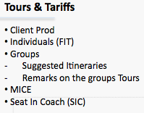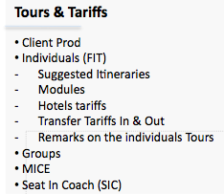Examples:

* See Annex: Zoning PowerPoint: ‘4- Tours & Tariffs’ *

* **Product Fact sheets**
* Sites
* Activities
* Hotels
* Cruises
* Restaurants
* Catering
* Spas
* Trains
* Vehicles

* See Annex: Zoning PowerPoint: ‘2- Fact sheet’ *

* **Useful information**
* Geography (Static map of the countries with a link to the ‘Maps’ section)
* Tips to prepare your trip
* Visa
* Climate
* Festivals calendar
* Gift ideas

* See Annex: Zoning PowerPoint: ‘5- Useful Information’ *

### 4.4 Practical Menu

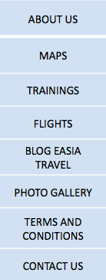

* This menu will be fixed throughout the website navigation
* The deployment of sub-sections shall not interfere with the visibility of other elements of the website
* The sections have to be **clickable** and allow **“Mouseover” / ”Mouseout”**
* The tab where the user navigates shall **be highlighted**
* The sub-menus will **close** when another section is clicked or when the cursor leaves the ‘action zone’
* The number of sections and sub-sections will vary (depending on some extensions, countries, etc.). The administrator will be able to add, move, modify and/or delete each section in the administration interface.

When passing the mouse cursor over one of the following sections:

**About us, Training, Flights, Photo gallery** and **Terms & conditions,** some ‘drop-down’ sub-sections will appear below.

When passing the mouse cursor over one sub-section, some other ‘drop-down’ sub-sections will appear below.

They will disappear when the mouse cursor leaves the ‘action zone’.

*See the web tree in Annex

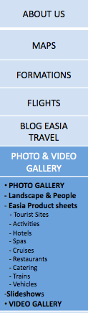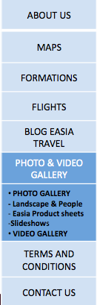

**8 sections in the Practical Menu**

**1) About Us**

4 sub-sections:

* Our offices (represented with a map + details)
* Our philosophy
* Sustainable travel
* Our partners

Resume the existing content (shorter version).

**2) Maps**

This section will provide **interactive maps.**

In the content area, 2 ways to navigate:

1. Navigation with maps on the left side
2. Navigation with text on the right side: list of countries/ regions/ cities/ products

Maps representing Southeast Asia: Vietnam, Laos, Cambodia, Myanmar + Thailand (not active for the moment), with highlight of the country where the cursor is.

Access to the maps with a “funnel” method: 5 countries > Country > Region > City

|  |  |
| --- | --- |
| Themes to choose on each City map:   * Sites * Activities * Hotels * Cruises * Restaurants * Catering * Spas * Trains * Vehicles | Sub-themes for hotels (‘Mouse over’/ ‘Mouse out’):   * Standard * Superior * First Class * Deluxe * Homestay |

Each map will display the products linked to the chosen theme. When clicking on one of the products (activity, hotel, etc.), the corresponding product fact sheet will open in a new window.

**Remarks:**

* On the map, possibility to zoom with the mouse and the ‘zoom bar’ (clickable + and - buttons)
* For hotels only: when the mouse cursor moves over a hotel, a bubble displaying the name of the hotel and the type (Classic, Deluxe, etc.) opens (as in Google Maps)

* See Annex: Zoning PowerPoint: ‘3- Map section’ *

**3) Training**

2 sub-sections:

* **Webinars**

Webinars (video recordings) will be available in this section.

The recordings will be presented as small vignettes + titles with links opening the videos in a new window (online player?).

The videos will be hosted on the BtoB website hosting server.

- Internal access: all video recordings.

- Client acess: Common general webinars + specific webinars available for certain clients only.

Below each video: a link to e-learning online questionnaires (these questionnaires will be created by Easia Travel) that will open in a new window.

* **E-learning**

This section will provide a knowledge assessment with online questionnaires.

These questionnaires will be rewarded with a **diploma system**.

Several success levels:

* <60% of correct answers: we recommend the user to repeat the training
* 60-80% of correct answers: the user has reached "Intermediate" level
* > 80%: the user is considered as "Expert"

The contractor will be in charge of setting up an accreditation system of knowledge to reward clients and Easia Travel staff~~.~~

- Internal access: all e-learning questionnaires.

- Client access: all questionnaires except the internal e-learning questionnaires.

Clients will be able to leave **comments** in this section.

**4) Flights**

2 sub-sections:

* **Domestic flights**

Access by country

- Companies: logos with links to the companies’ websites

- Flight Tariffs: a content filter for the flight tariffs already exists in the current BtoB website. Access to the Flights table (It is currently on Excel format)

* **International flights**

- Companies: logos with links to the companies’ websites

- Sales Offices (by market + Key Contacts: Name, Title, Address, email, mobile, etc.).

**5) Blog**

Link to the blog => open in a new web page.

**6) Terms and Conditions**

3 sub-sections will appear in the content area:

* FIT
* GIT
* MICE

**Customizable** for ‘main’ clients (about 10 per market) => these clients will only see the Terms and Conditions that apply to them.

**7) Photos / Videos**

2 sub-sections:

* **Photo Gallery**

2 sub-sections in the Photo Gallery:

* Landscape & People
* Easia Travel products (Sites, Activities, Hotels, Cruises, Restaurants, Catering, Spas, Trains, Vehicles)

This section will contain a specific search engine, with photo search by:

* Country
* Region
* City

* See Annex: Zoning PowerPoint: ‘6- Photo Gallery’ *

* **Video Gallery**

We do not have any video content at the moment.

It will have to be easy to add content and to create sub-menu later.

=> ‘vignette’ system + title opening the video in a new window (Youtube link?).

**8) Contact Us**

4 sub-sections:

* Our offices in Asia (static map + presentation of our sales staff in Hanoi: 1 form per confirmed sales executive with photo and short description)
* Our offices in Europe (static map + contact details)
* Emergency contacts
* Ask for a quote (link to ‘Ask for a Quote’ section)

### 4.5 Clients and Easia Travel comments

Easia Travel staff and clients will be able to **leave comments** in the following sections:

* Product Fact sheets
* Tours & Tariffs
* Training
* Ideally, comments left by people from the same company will be visible for all the people in this company having access to our website
* ‘See previous comments’ link below the comment box
* When clicking on this link, a new window will open, displaying the comment history from the users of the same company

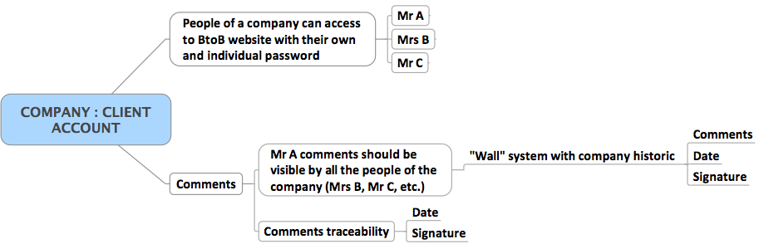

* Ideally, the same system would be implemented for comments from Easia Travel’s staff.

The service provider will propose the right solution for the comment history “wall”.

### 4.6 Product Fact sheets

* **Product fact sheets section**

*See Annex: Zoning PowerPoint: ‘2- Fact sheet’ *

These zonings were created for informational purpose, in order to provide maximum features about the pages and to show the navigation system.

**These zonings are not a guide to the graphic design.**

The major innovations in this section are:

* A “**Point of view**” tab:

- Easia Travel point of view: opinion/ analysis of the products

- Client/ Staff comments: text box + a link to previous comments (which will open in a new page).

- TripAdvisor: link to the concerned product on TripAdvisor website

* **Preferences system**: this system will allow our staff to improve the client’s product specifications: clients can ‘catalog’ their preferences on a particular product.

One box to tick among 3 choices for each category in each product (see the web tree):

- Priority

- Back up

- Blacklist

After choosing their preferences, users have to click on a “Save my preferences” button

=> it will automatically send an email alert to our sales team, who will in consequence amend the client production specifications.

* **Tariffs:** tariffs tab to be included in all the product fact sheets. At the moment, we do not know exactly which fact sheets will need the ‘tariffs’ tab (we will decide later).
* **Gallery**:

- Photo Gallery

- Video Gallery

Include a **Google Map below each Product fact sheet** to locate the product (as in the current BtoB website for hotels)

* To be applied in the following sub-sections: Sites, Activities, Hotels, Restaurants, Spas and Catering.

**GPS coordinates for locating the product will be visible**

* **Downloadable Product Fact sheets**

Downloadable Fact sheets are currently available for consultation in **XML format** and downloadable in **Word format**.

The client will be able to download the Product fact sheets in Word Format, and to customize them.

*See current BtoB website Product fact sheets.

Existing problems with downloadable Product fact sheets today are:

* Very long download speed (probably due to the hosting solution?)
* Incorrect layout (Word format) and pictures often do not appear.

=> **It is important to fix these problems**.

## 5- Technical expectations

Technical development should enable this new site to **be upgraded in the future** (adding new sections, different language versions, etc.).

### 5.1 Technical solution

Easia Travel is open to a **dedicated CMS** or **open source CMS** solution.

The solution should allow a free and independent content management and easy updates.

* The key words are**: easy to use, intuitive, responsive, flexible and expandable**

This should allow:

* To be able to add new content (text, photos, videos…) through a simple and independent interface
* To easily integrate specific functionalities (new sections, etc.)
* To easily do updates (with web update interface)
* To have a “user-friendly” back office for administration

All theses modifications have to be possible, after the new BtoB website launch, **without the contractor’s help**.

* Easia Travel wants that The BtoB website must be compatible with the majority of current browsers (Chrome, Firefox, Safari, IE8).

A Responsive design website seems appropriate (depending on the cost estimation).

* The back office must allow adding or removing additional languages from the administration interface. It has to propose **multilingual system**.

The **Btob website will look the same way for different languages** (English, French, German, Italian…)

Functionalities of the technical solution should be detailed in the service provider offer.

### 5.2 Users Management and Access Control

Easia Travel expects a users Management function and a secure access, fully customizable via the back office.

A system of **personalized passwords will allow access to specific content depending on the users**.

The administrator will therefore define who has access to what content.

**The user accounts creation will be possible via the back office.**

We estimate the number of passwords needed around 2000.

Different levels of access with passwords:

* Client (one password per person, even for several people from the same company)
* Easia Travel staff and targeted people

Each Client and each person of Easia Travel staff will have their own customizable password.

|  |
| --- |
| BtoB website Connection |
| A login screen will be displayed before access to the homepage. |
| The user should enter his login and password. |
| **Selective information diffusion** |
| The access to the contents will be defined for each client*.* |
| Depending on the visitors profile, **the client name will appear in the header**: “Hello Mr., Mrs…” |
| The ‘My Production’ section will be available for about 10 clients per market. |
| Passwords will be personalized by the users to make the memorization easier.  Easia Travel will have the possibility to get those passwords back for an efficient follow-up. |

A “**Remember Pass**” system should be effective.

**For safety reason, the password management system has to be very secure.**

*See Annex: Zoning PowerPoint 0-Login Page*

### 5.3 General search engine

A general search engine will be visible **in the top right-hand corner** of the website, and will **be fixed on all pages of the website**.

It must allow to search through the content in all the website (pages, documents, sheets…).

It should offer **auto completion** and provide a fast and coherent information search.

The contractor will define the search engine rules for relevant results and respecting the following points:

* The syntax for research should not be too restrictive – for example it should take accents, small and capital letters into account.
* The search results will be displayed according to their relevance (occurrences of keywords in the title and in the contents of the pages).
* New contents recently added will be taken into account in the search.

The contractor will explain in his offer the search engine functionalities, and will provide examples of websites where this engine is integrated.

|  |
| --- |
| Search perimeter |
| The search engine will search by default in the website contents. |
| **Display list of results** |
| When the search input is done, a scroll menu will appear, even if the users do not use accents or capital letters |
|  |

### 5.4 Content filters

In some sections **content filters** will be integrated, allowing the user to search for information in a specific content.

The research fields will be defined according to the web tree.

The content filters of the BtoB website should take each new content added by Easia Travel into account

=> It **should be easy to configure**.

If a new destination is added, we also need to incorporate content filters via the administration interface in this new destination.

**The search fields** (proposition tabs) **have to be independent from each other**.

|  |
| --- |
| Search perimeters |
| The content filters will search by default in the content of the concerned section.  Drop-down tabs (country, region, city, category, etc.) will **offer choices of themes** according to the website tree (for example see specific search engines in the current BtoB).  Drop-down tabs will have to **be independent from each other** to facilitate the search. |
| **Display list of results** |
| When the input in ‘name box’ is done, a proposition scroll will appear, even if the users do not use accents or capital letters. |
|  |
| **Request storing** |
| *The searches entered by users will be stored in a file or the website server, allowing to draw statistics.* |

### 5.5 Hosting

The BtoB website must be accessible 24/7.

The hosting server thus has to provide **a good connection speed for users** through an appropriate and upgradeable technology.

The BtoB website will be used in **Europe, Asia** and **United States**.

The hosting should therefore propose an optimal connection in these countries, especially Europe and Asia.

We are expecting from the service provider an adapted proposal for the hosting.

**An English-speaking hosting service will be preferred.**

In the proposal, please send us the details of hosting infrastructure:

* Hosting features
* Method of intervention
* Failure recovery
* Availability rate
* Data security and back-up

**Website Domain name:**

The name of the BtoB website will remain the same: [www.easia-pro.com](http://www.easia-pro.com)

### 5.6 Contents migration

The contractor will ensure the transfer of the old BtoB website contents to the new BtoB website.

The current BtoB server that we using is windows server 2003. The Database : SQL Server 2008 and ASP.net framework : 4.0.

The total data volume of the BtoB is 320GB, and the current BtoB website used 150GB.

**Contents and database to be transferred from the old website:**

* Data in XML format.
* Text contents (some modifications will be done on certain parts) => Word, PDF format.
* Table contents (some modifications will be done on certain parts) => Excel files.
* Photo and video contents (photo gallery + product fact sheets + webinars)

The total number of pages we currently have in the BtoB is about 23.000 pages per language (so for 5 languages it is potentially about 23.000*5 so 115.000 pages)

The total number of Photos on the BtoB is about 111.000 Files – so 75,7GB.

It will be **reorganized according to the new BtoB tree website**.

**The website will be translated into several languages** – Easia Travel will provide the translated contents.

### 5.7 Maintenance and warranty services

* **Preventive, corrective and upgradeable maintenance**

Maintenance services will be performed under the following conditions:

The contractor will commit to ensure the operational maintenance of all the elements of the B2B website as a precaution, in order to avoid the incidence of anomalies, and to fix any noticed anomaly.

The contractor will namely commit to update all the components of the proposed technical solution that could create stability or security problems.

Any maintenance operation planned by the contractor and that could lead to a service shortage will have to be announced 5 working days before. Easia Travel reserves the right to ask for an adjournment or cancellation of the maintenance operation.

* **Warranty**

Services will be guaranteed by the contractor during 6 months after the new B2B website is online. During this period, any intervention by the contractor will be cost-free.

After this 6-month period, the maintenance contract will be tacitly renewed each year at due date.

The warranty includes any design defect or abnormal functioning, may it be visible or hidden.

In case of a malfunction of their solution, the contractor commits to act within 24 hours to prevent service shortage. Interventions not leading to service shortage will be possible within 24 hours.

Any malfunction will be signaled and acknowledged via e-mail by Easia Travel.

### 5.8 Security

The confidentiality and integrity of the information provided by Easia Travel is primordial. A high level of security is capital.

## 6- Service provider selection

### 6.1 Main expectations of the Btob website

|  |
| --- |
| Main expectations : |
| An **intuitive, “user-friendly”, adjustable** and **extensible** website |
| A professional visual identity – s**imple** and **uncluttered** |
| A website that adapts to different screen sizes |
| P**ersonalized passwords** that allow specific access to each client |
| A **personalized area** for main clients with the history of their specific tailor made programs (My Production) |
| An interactive **Maps** section |
| A **Training** section |
| ‘**Flexible**’ quotation forms |
| Allow **comments** in certain sections |
| Efficient search engine |
| Efficient **statistics tools** |
| A **multilingual** website |
| Operate contents migration in the new BtoB website |
| Create pictograms |
| Find **a suitable hosting solution** |

### 6.2 Financial and technical proposals

Financial and technical proposals have to be presented legibly, explicitly and detailed in accordance with the following positions:

* Project management
* Functional and technical ‘design’ (details of each post)
* Graphic design (details of each post)
* Technical development (details of each post) and online launch
* Hosting
* Maintenance (details of each post and intervention deadline)

Each detailed post will allow to identify, for each service: the price with and without taxes, technical and legal details, and the teams dedicated to each step.

### 6.3 Criteria for proposals selection

Proposals will be reviewed and classified according to the following criteria:

* The compliance of the offer with the present requirements document
* The technical and graphic quality of the proposed solution (a model of the homepage and an internal page will be provided with the quotation)
* The production deadline
* The composition and experience of the dedicated team project
* The previous achievements and references of the service provider
* The budget quotation with and without taxes, for each post

There is no hierarchy between the criteria. The quality of the report will prevail; references and prices will be preferred.

### 6.4 Proposals submission

The service providers have to submit their proposals via email before the july 24th 2014:

Mr Maxime TEMPERMAN

Web Projet Manager

[weblillea@gmail.com](mailto:weblillea@gmail.com)

Melle Camille FAVROT  
Marketing & Communication Manager

[camille@easia-travel.com](mailto:camille@easia-travel.com)

### 6.5 Execution method

Any full proposal received by the deadline will be examined and will receive an answer.

Incomplete proposals will be systematically excluded from consultation.

In late July, the proposals will be shortlisted and the selected service provider might be subject to an audition by Easia Travel.

Following the auditions and after deliberation by Easia Travel, the shortlisted service providers will be informed of the outcome of the consultation~~.~~

The selected service provider will sign a contract, which will include especially the elements of the present requirements document, and will also determine all the financial provisions and administrative arrangements.

## 7- Method

### 7.1 Provisional schedule

The BtoB website should be delivered and launched online in end of December 2014.

The website delivery note will be signed by both parties.

Three month after its reception and its installation, a report on the functioning of the BtoB website will be made.

The contractor shall provide a schedule detailing the key steps in design and construction of the project, and the deadlines for the expected deliverables.

For tasks requiring many validations, the contractor will have to provide regular intermediate states of his work.

### 7.2 Expected deliverables

The elements to be delivered by the contractor during and after the production of the BtoB website are:

* Project completion schedule with the proposed online launch date
* A document describing in detail the contractor proposals
* Functional and technical specifications (technical and software architecture of the project, functionalities, etc.)
* Documents describing the website, its functioning and its hosting (if the hosting is validated by Easia travel)
* Additional integrated modules
* The website source files (HTML pages, graphics, databases, programs…)
* Documentation or training manual of the website for administrators (updates, daily management, integration of new sections, etc.)

### 7.3 Budget

The service provider will offer cost estimations corresponding to the services defined in this requirement document.

It may separate certain services (including hosting and maintenance) as options.

### 7.4 Rights and property

The rights and properties of contents, graphics, iconography, and all the elements of this new BtoB website (interface management, source code, etc.) will indefinitely and entirely belong to Easia Travel.